In the Latex, everything before “to conduct the comparison” should be fine, except for my green comments where I didn’t know….

To conduct the comparison of algorithms, a movie of 500 frames was chosen and segmentation and tracking were done. On this data, both detection methods were run. The trajectory-based method was run for different smoothing parameters, ranging from 0.2 to 4.0 in steps of 0.2. Jibbs maybe has to re-run his simulations for higher smoothing params as it just gets better and better!
The fluorescence-based method was run with fixed parameters, as its parameters were already optimized for that movie during its development (the main optimization can be done by changing the factor $\mu$ which decides how many times brighter one pole should be compared to the opposite pole).
From the resulting dataframe of each method, the reversal time, cumulative path-length of the skeleton center and the corresponding tracking ID were extracted. Since the trajectory-based method excluded more tracking IDs (=trajectories) than the fluorescence-based method, only the tracking IDs of the trajectory-based method were taken into consideration.
The total amount of reversals could then be seen. While for the fluorescence-based method a fixed value of 2245 reversals turned out, the amount of reversals detected by TM ranged from 7458 to 1439. Figure ... shows the variation of total reversals with smoothing parameter.

WHY DOES THE AMOUNT OF ACCEPTED REVERSALS DECREASE???
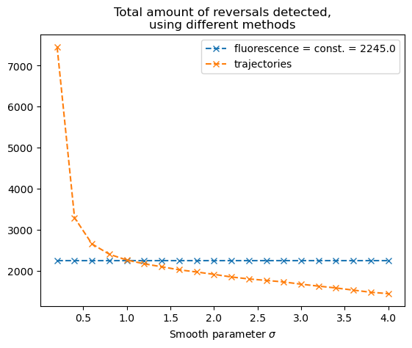
The next goal is to see if the two algorithms found the same reversals.

Briefly, the algorithm comparison works like this: Assuming that FM is correct, we go through all the FM reversals and see if a TM reversal event occurs nearby. Nearby means a time distance of +-20 frames or, taking an avg speed of 4 um/min, 2.66 um. How did we come up with that value?

There are 2 methods to obtain close_time / close_distance: 1st Best: (what we didn’t do – get few times the standard deviation of the time between trajectory change and sgmx change + 5 frames delay between mine and his algorithms due to him taking photos every frame and me only every 5 frames). I estimated that as typically +-15 frames (30s) difference and +-5 seconds delay due to fewer fluorescence photos, briefly looking at 10 reversals. I made my estimation only on very little evidence though!
2nd (what JB and me did, which I find very bad now: min tbr + 5 frames delay between mine and his algorithms due to him taking photos every frame and me only every 5 frames + 5 frames estimated deviation between trajectory change and sgmx relocation. -→ discard this! Just a reminder for JB to compare what I did not vs what we discussed before.

For 2nd method:
We know from the FM analysis that the 5-percentile of the time between reversals is 70 seconds (35 frames), i.e. 95% of the tbr are longer. Thus we end up with +- 35 frames (70s) of tolerance for TM.
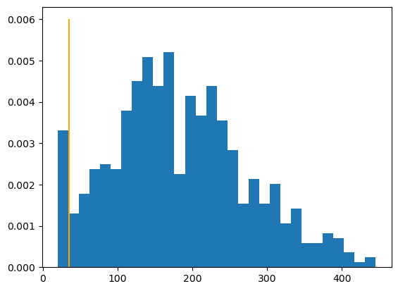
There is no reversals allowed between 5,10 or 15 frames in fluorescence detection method, thus the diagram starts at 20. The peak could be explained that a part of the tbr=20 is due to pollution, resulting in short time misdetection of the FM, counted as 2 reversals.

Before comparing the two algorithms, some reversal events are going to be filtered out, in order to make the comparison “fair”.
Firstly, only reversal events are going to be considered that occur with sufficient distance from the trajectory start or end. The reason is, that the TM needs to gather sufficiently long trajectory information in order to smoothen the trajectories. This is why in the TM all reversals which occur with a distance (related to travelled path length) smaller than the smoothing parameter from the trajectory start or end are filtered out by the TM algorithm.

Subsequently, it would only be fair to consider FM reversal events that are also far from the trajectory start or end. We finally only accept reversal events that occurred after the smoothing parameter, introducing a little error. If an FM reversal event was spotted just after the smoothing parameter, the comparison would maybe not detect the corresponding TM reversal event, as it might just have happened before, i.e. been excluded if it occurred before the pathlength of the smoothing parameter. This error is nevertheless small, as on long trajectories only few reversals lie on the trajectory beginning or end.

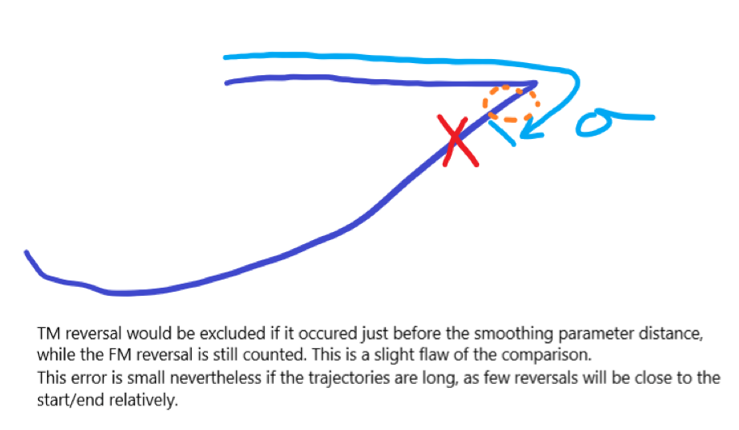

Secondly, we will only consider reversals on bacteria that did not touch the boundary in the last 50 frames or will not touch it in the next 50 frames. As discussed before, the FM can not detect reversals close to the boundary. Jbs method could also have problems with that, but he didn’t exclude these events. Its not problematic for the comparison though, as I filter out these reversals in the comparing program.
While the first step looked that TM is not in the disadvantage, the second step cares that FM is not in the disadvantage.

After filtering out reversals, we end up with the total number of "acceptable" reversals.
The comparison of reversal detector can now be conducted on the subset of all reversals of the TM and FM that a) occur with sufficient distance form the trajectory start or end and b) lie on bacteria that did not touch the boundary in close times.
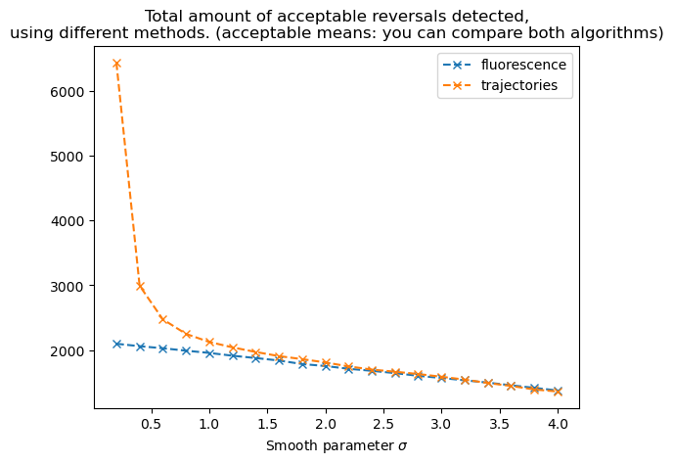
The algorithm goes through all acceptable reversals of the FM and looks if it can find one reversal from the TM in close enough times or travelled path lengths.
If a close reversal was found from the TM, we count one match and remove this reversal from being considered.

Finally, a match fraction can be computed. We define the match rate = 2*matches / (total amount of acceptable reversals),
total amount of acceptable reversals = # acceptable FM reversals + # acceptable TM reversals.
This match rate checks if each match actually takes away two reversals from the list of all reversals and thus also cares about overdetection. Jibbs has another idea: denominator minus m, numerator just 1m
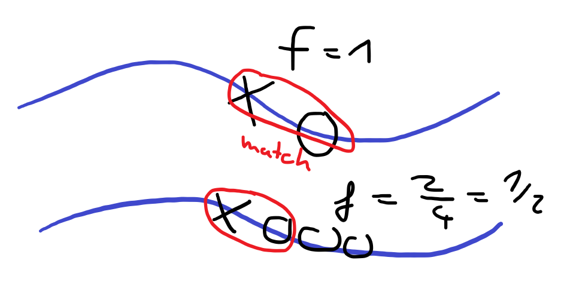This image illustrates how the match rate would look like if we only had one trajectory, a) with 1 fluo reversal and 1 traj reversal, b) with an overdetection by traj reversal, e.g in the case of low smoothing params
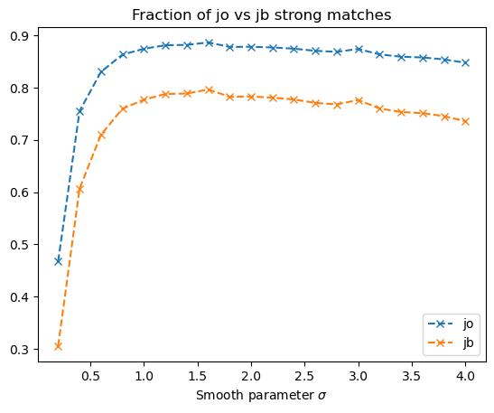

CONCLUSION: JIBBS ALGORITHM (TM) could be used for higher smoothing parameters (1.2-2.4). Assuming that the fluorescence-based algorithm has an accuracy of 100%, TM has an accuracy of 90%! In practice, FM has an accuracy of 90% (maybe higher, JB HAS TO CHECK THIS AGAIN VIA COUNTING), meaning that TM would have an accuracy of ?????? % (can we make some conclusion via statistics).
There are arguments to think that TMs accuracy might also be lower in practice than with this test statistic/ testing procedure. If you look at the graphic below, errors like this could occur! Obviously jibbs double reversal is a mistake, something that has never been found, my fluo reversals have not been captured by his algorithm, but still this could count as a double match.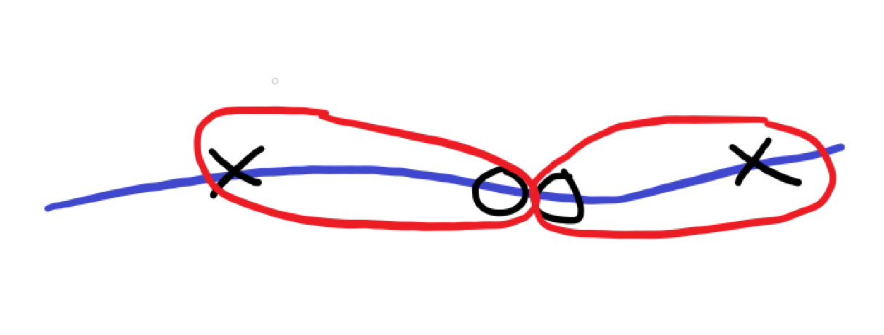

Also, determining of the accuracy had slight errors becoming negligible for longer trajectories. How do I know this? I took 10*smooth param instead of smooth param and the match rates stayed the same.

But to obtain this accurate precision of his algorithm, we must never forget to remove the reversals which occur shortly after a bacterium touched the boundary of the domain (JB HAS NOT IMPLEMENTED THAT YET).
We could also increase the accuracy by only considering long trajectories, to avoid segmentation mistakes.

Data for the plots:

smooth_parameter_list= np.arange(0.2,4.2,0.2)
total_trajectories_with_reversals_list = [2836., 2113., 1914., 1820., 1791., 1769., 1756., 1739., 1739., 1731., 1726., 1726., 1727., 1725., 1717., 1715., 1717., 1711., 1709., 1713.]
total_trajectories_with_reversals_fluo_list = [1649., 1649., 1649., 1649., 1649., 1649., 1649., 1649., 1649., 1649., 1649., 1649., 1649., 1649., 1649., 1649., 1649., 1649., 1649., 1649.]
total_trajectories_with_reversals_traj_list = [2808., 2049., 1827., 1717., 1664., 1621., 1591., 1545., 1528., 1500., 1468., 1437., 1418., 1395., 1358., 1328., 1303., 1275., 1238., 1216.]
fluo_total_reversals_list = [2245., 2245., 2245., 2245., 2245., 2245., 2245., 2245., 2245., 2245., 2245., 2245., 2245., 2245., 2245., 2245., 2245., 2245., 2245., 2245.]
fluo_total_acceptable_reversals_list = [2097., 2059., 2027., 1990., 1955., 1912., 1876., 1838., 1783., 1753., 1710., 1679., 1643., 1601., 1568., 1532., 1496., 1455., 1415., 1375.]
traj_total_reversals_list = [7458., 3291., 2651., 2399., 2258., 2166., 2094., 2020., 1967., 1909., 1845., 1797., 1761., 1724., 1669., 1622., 1577., 1524., 1472., 1439.]
traj_total_acceptable_reversals_list = [6443., 2994., 2474., 2249., 2125., 2041., 1970., 1906., 1859.,1808., 1747., 1698., 1665., 1629., 1587., 1543., 1490., 1445., 1390., 1359.]
total_acceptable_reversals_list = [8540., 5053., 4501., 4239., 4080., 3953., 3846., 3744., 3642., 3561., 3457., 3377., 3308., 3230., 3155., 3075., 2986., 2900., 2805., 2734.]
jo_strong_match_list = [0.46744731, 0.75519493, 0.83048212, 0.86341118, 0.8745098 , 0.88135593, 0.88195528, 0.88675214, 0.87808896, 0.87840494, 0.87706104, 0.87474089, 0.87061669, 0.86873065, 0.87416799, 0.86373984, 0.8593436 , 0.85793103, 0.85418895, 0.84784199]
jb_strong_match_list = [0.30501222, 0.60667727, 0.71010638, 0.75965131, 0.77700348, 0.78787879, 0.78883721, 0.79654511, 0.78267254, 0.78317476, 0.7810407 , 0.77736842, 0.77087794, 0.76792556, 0.77646396,
0.76016027, 0.75337639, 0.75120773, 0.74548849, 0.73587302]
weak_match_list = [0.95183596, 0.92666343, 0.92205229, 0.91959799, 0.91253197, 0.91108787, 0.90405117, 0.9031556 , 0.89680314, 0.89218483, 0.88654971, 0.87969029, 0.87644553, 0.8763273 , 0.87946429, 0.86684073, 0.85762032, 0.85498282, 0.84664311, 0.84290909]
matches_list = [1996., 1908., 1869., 1830., 1784., 1742., 1696., 1660., 1599., 1564., 1516., 1477., 1440., 1403., 1379., 1328., 1283., 1244., 1198., 1159.]
kicked_min_distance_to_traj_star_or_end_list = [125., 55., 35., 34., 28., 26., 33., 28., 29., 29., 30., 35., 35., 35., 27., 25., 33., 27., 32., 32.]

